Final keyword->

*The **final keyword** in java is used to restrict the user.

*The java final keyword can be used in many context. Final can be:

1. variable
2. method
3. class

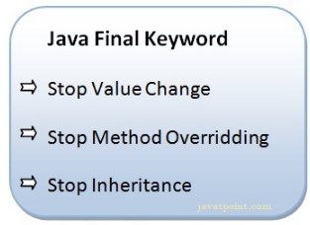

*The final keyword can be applied with the variables, a final variable that have no value it is called blank final variable or uninitialized final variable.

*It can be initialized in the constructor only.

*The blank final variable can be static also which will be initialized in the static block only.

#how to make final just put keyword before variable .

1.Java final variable->

*If you make any variable as final, you cannot change the value of final variable(It will be constant).

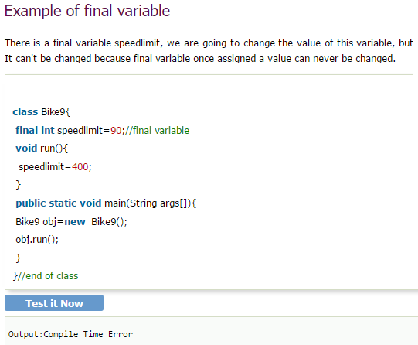

2.Java final method->

If you make method final then ,you can not override it.

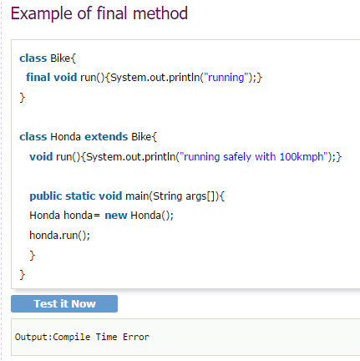

3.Java final class->

If you make any class final then you can not extend it.

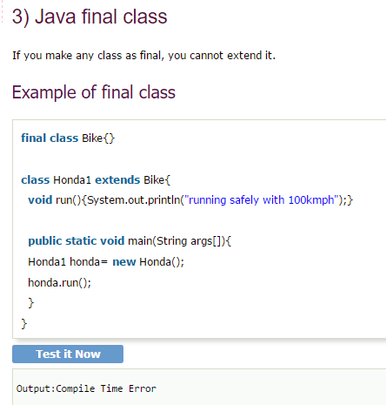

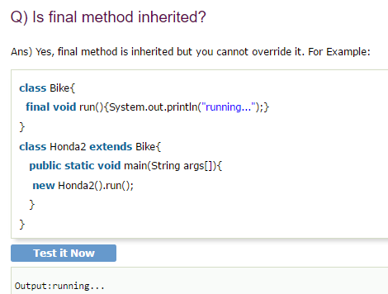

Q) What is blank or uninitialized final variable?

* If we can’t initialize the final variable then its called uninitialized final variable.

* It can be initialized only in constructor.

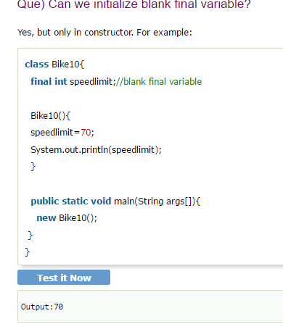

### static blank final variable->

### if the blank final variable is static then its static blank final variable.

And it can only be initialized in static block;

